TASK – 2

Create 3 instances, install nginx, and apply ALB

ALB – Application Load Balancer

Create a Security group and create 3 instances with different availability zones. Install Nginx for 3 instances, Create target groups with 3 created instances. Attach the created target group with the load balancer.

This is done because of balancing the traffic or data between 3 instances.

Let us go:

Create Security Group

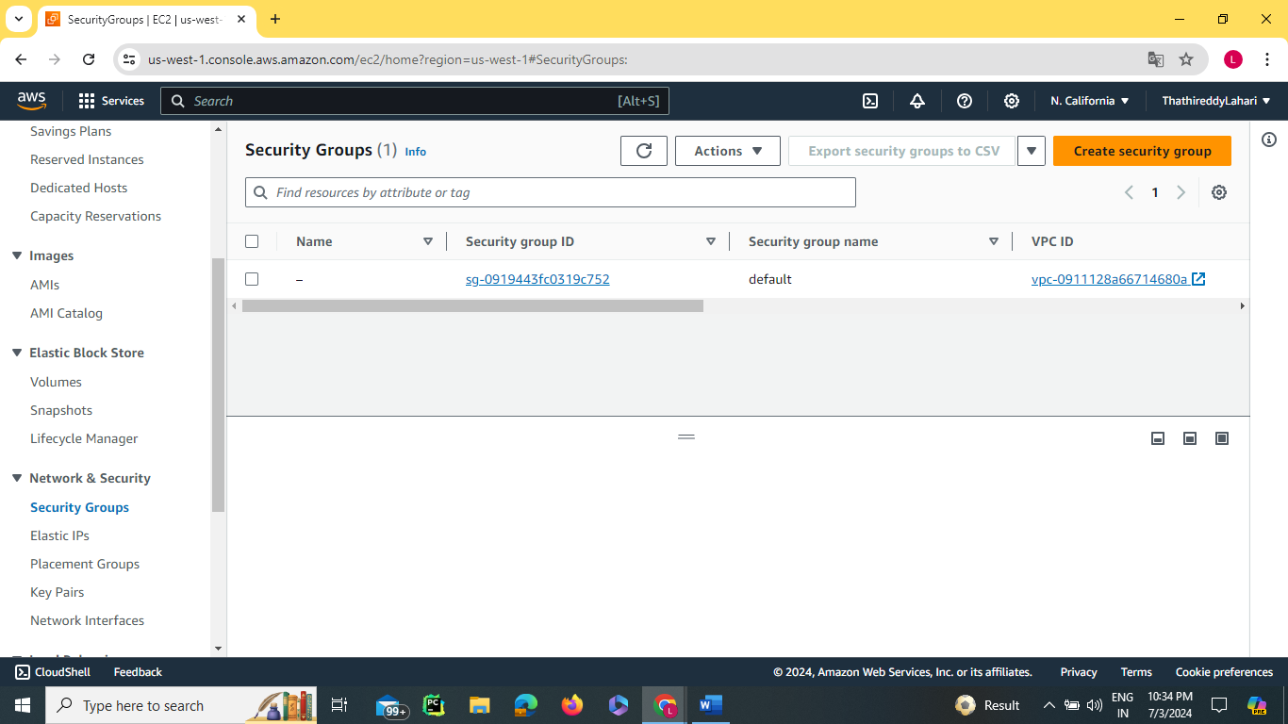

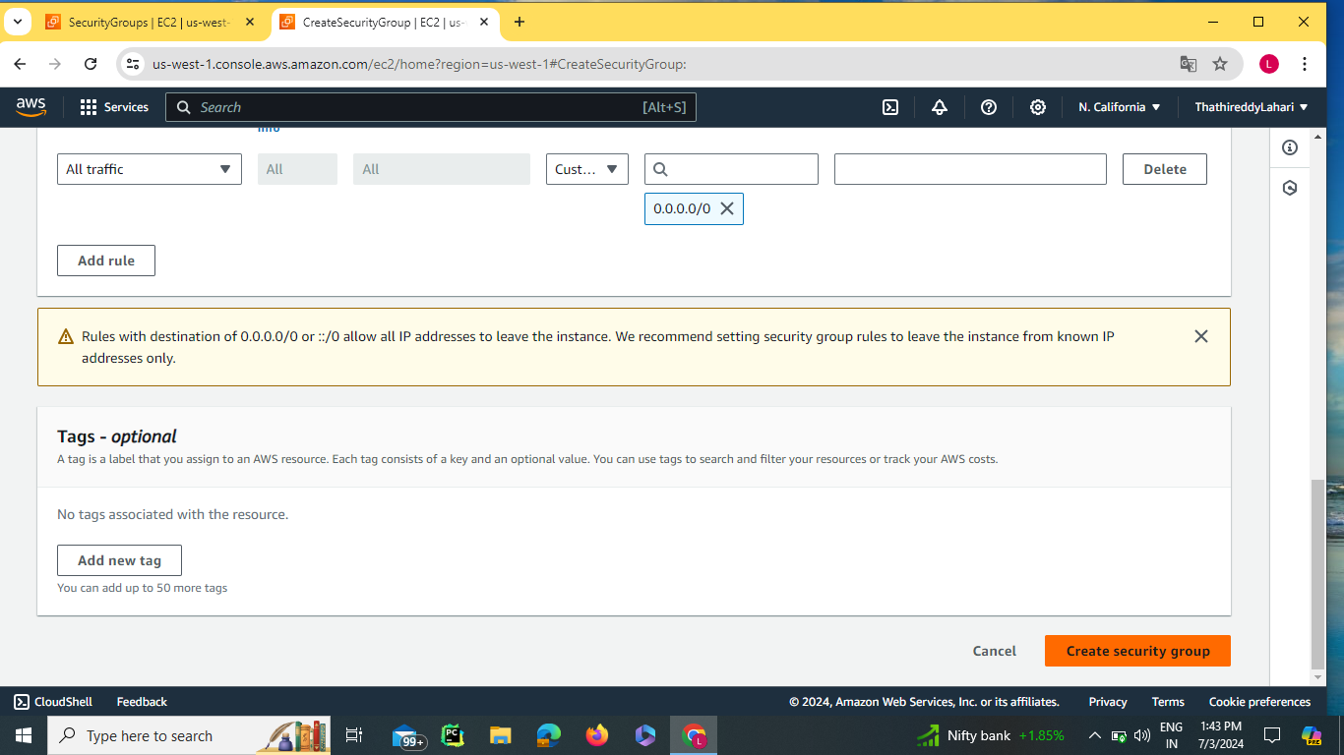

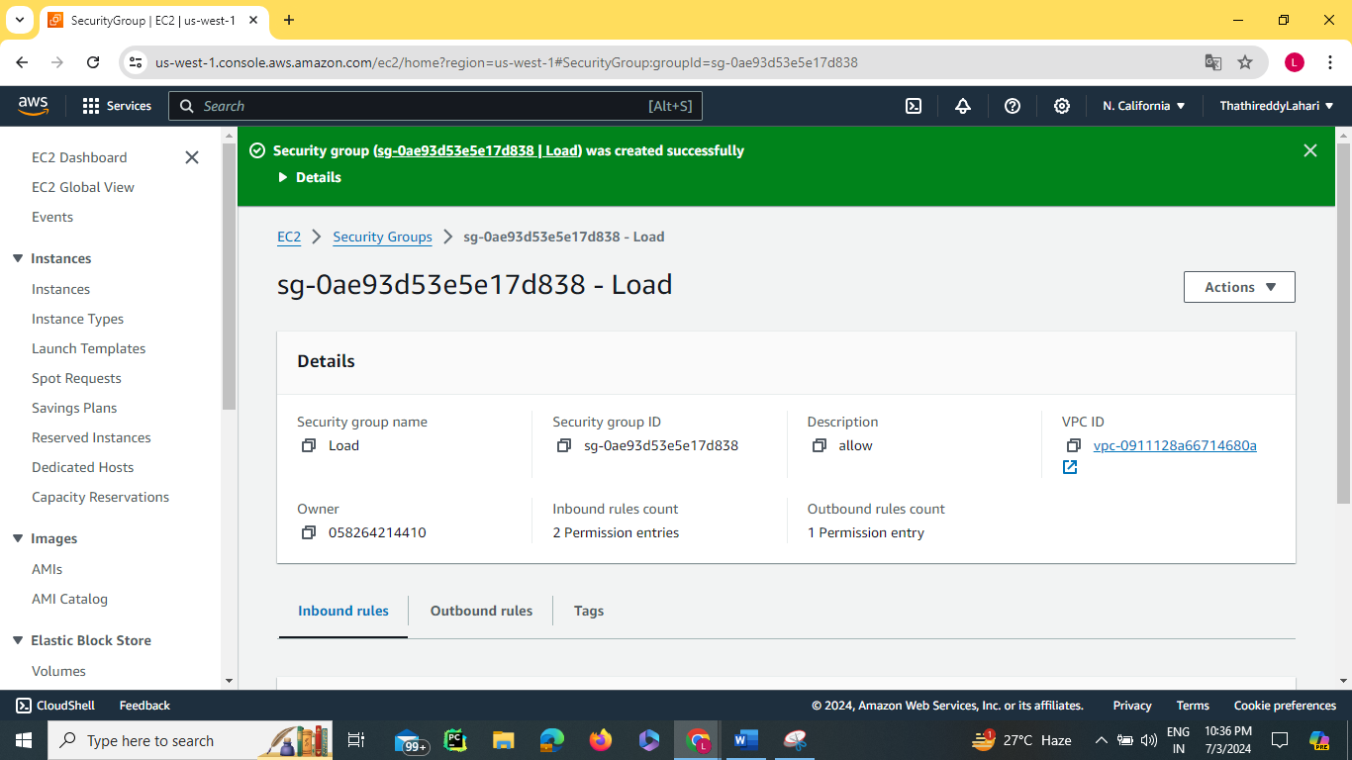

Launch 3 instances with different availability zones

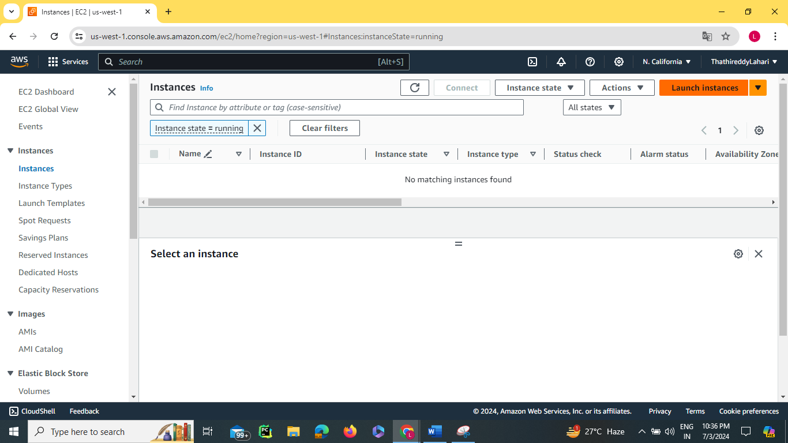

Create a new key pair

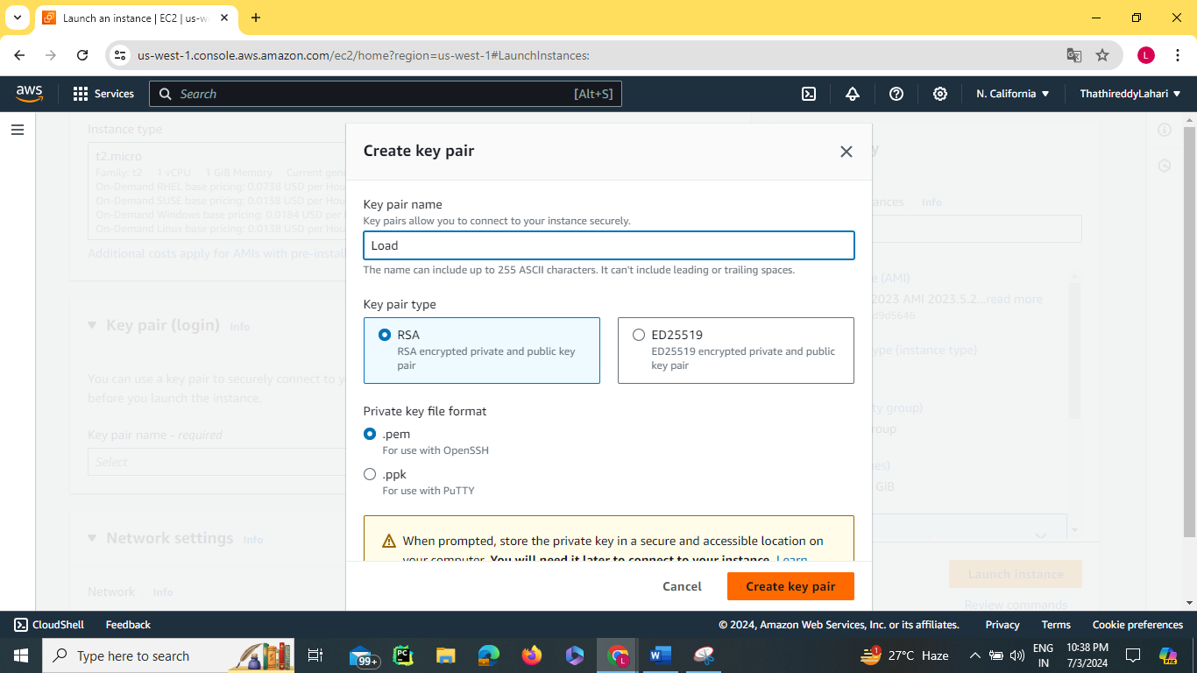

Edit Network Settings Subset with different availability zones for different instances and select existing security group which we are created for security group

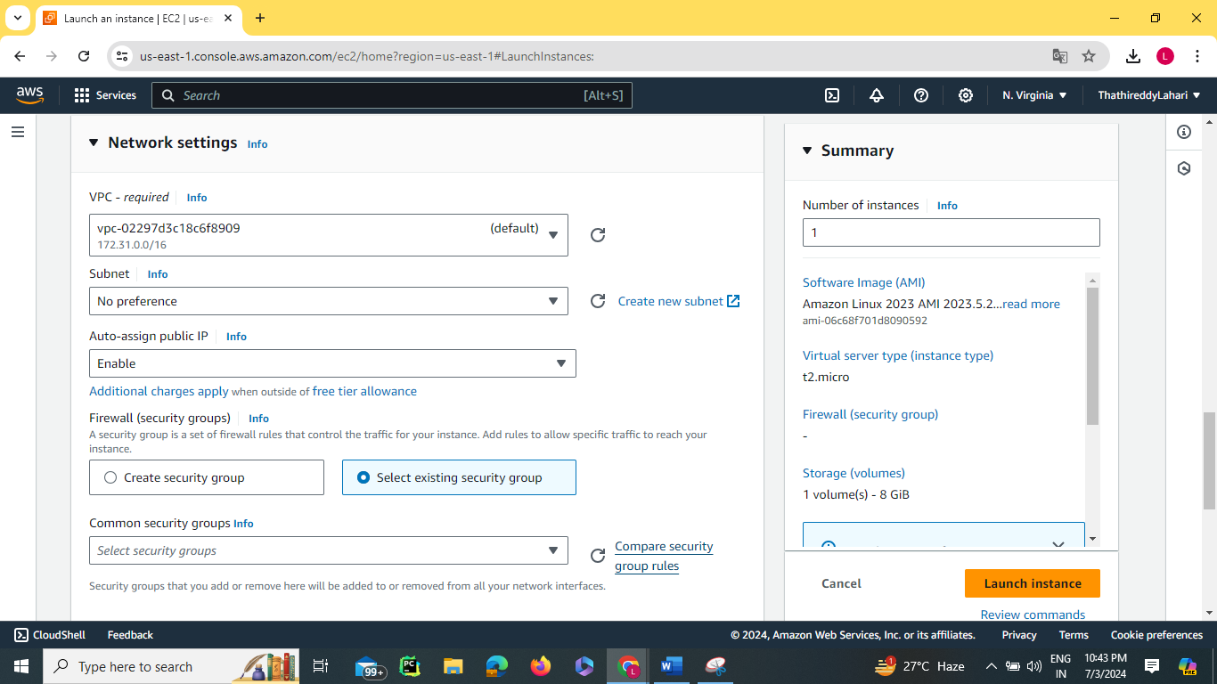

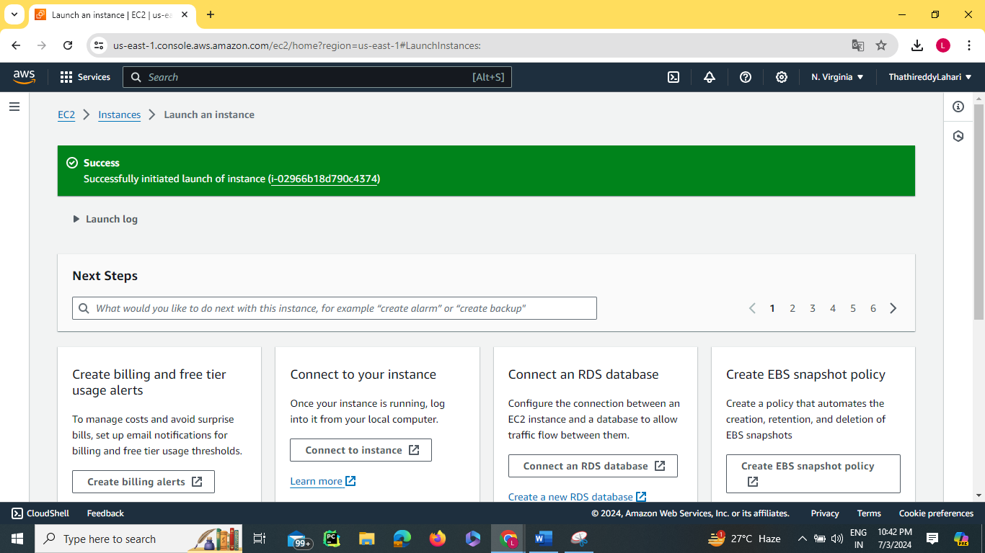

The above one shows the Instance launched successfully.

As shown above, make the remaining two instances with different subsets with the same key pair. Below one shows the three instances launched.

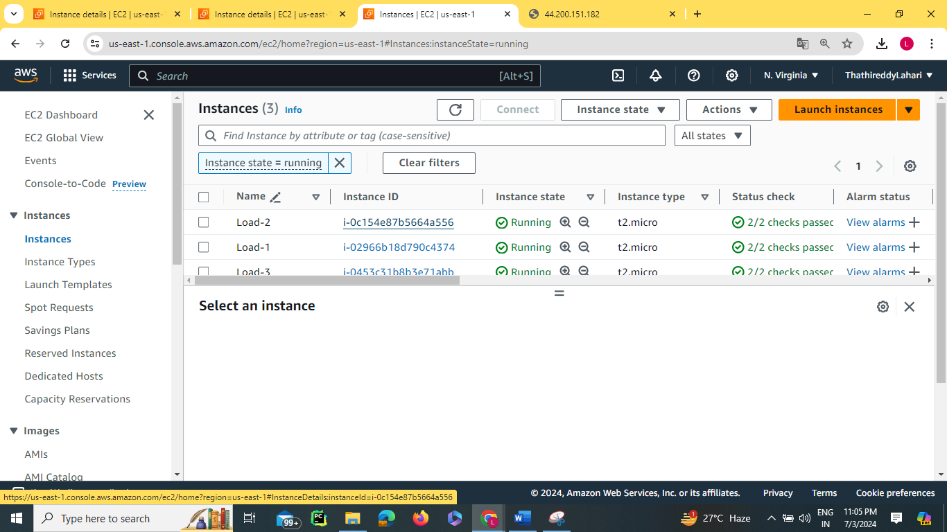

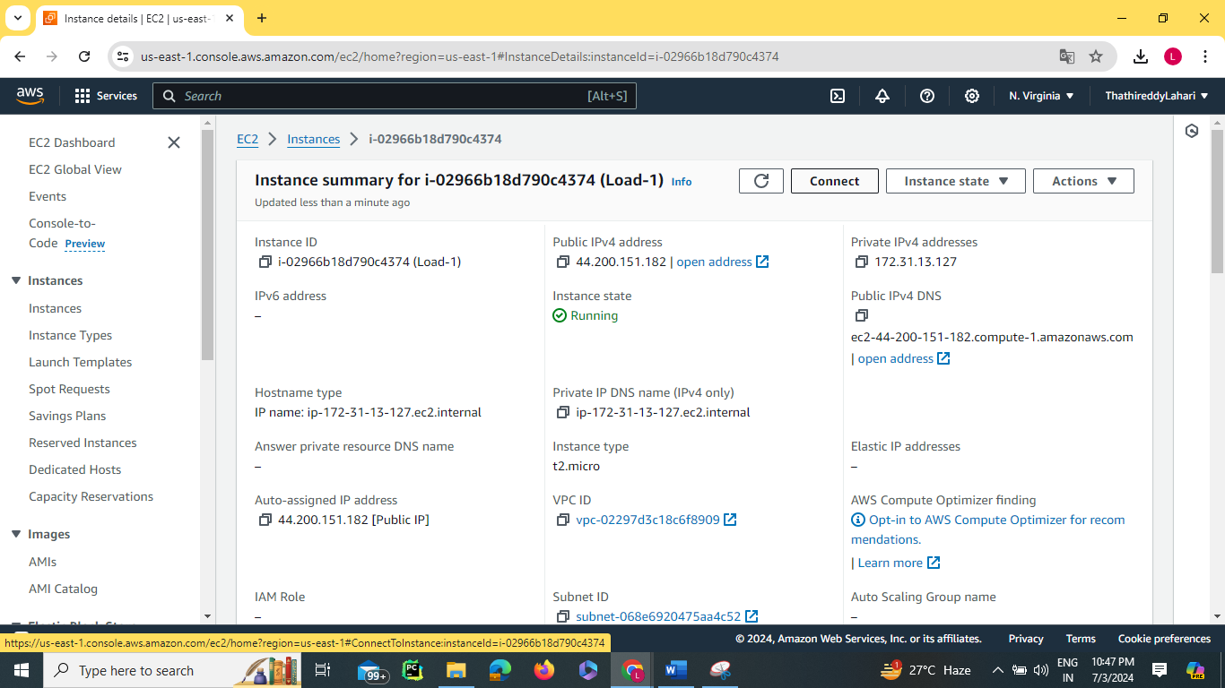Go to instance 1 and click on connect its shows as below

Click on Ec2 instance connect , click on connect

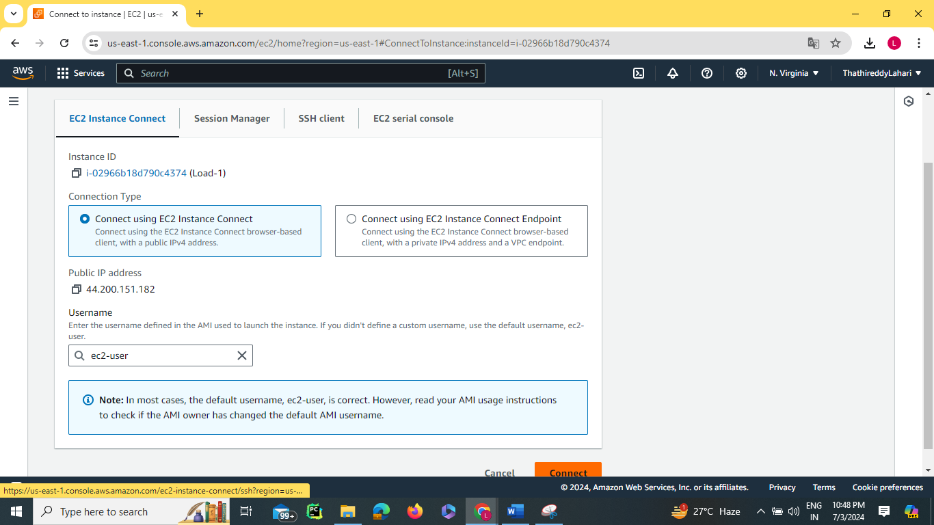

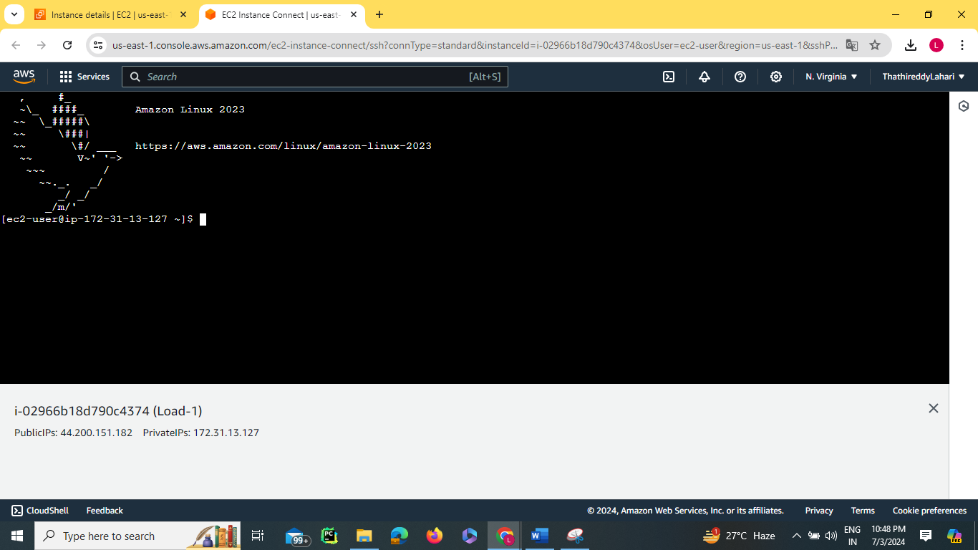

to become a root user use sudo -i

For the nginx install first go through with the yum update -y

Then yum install nginx -y

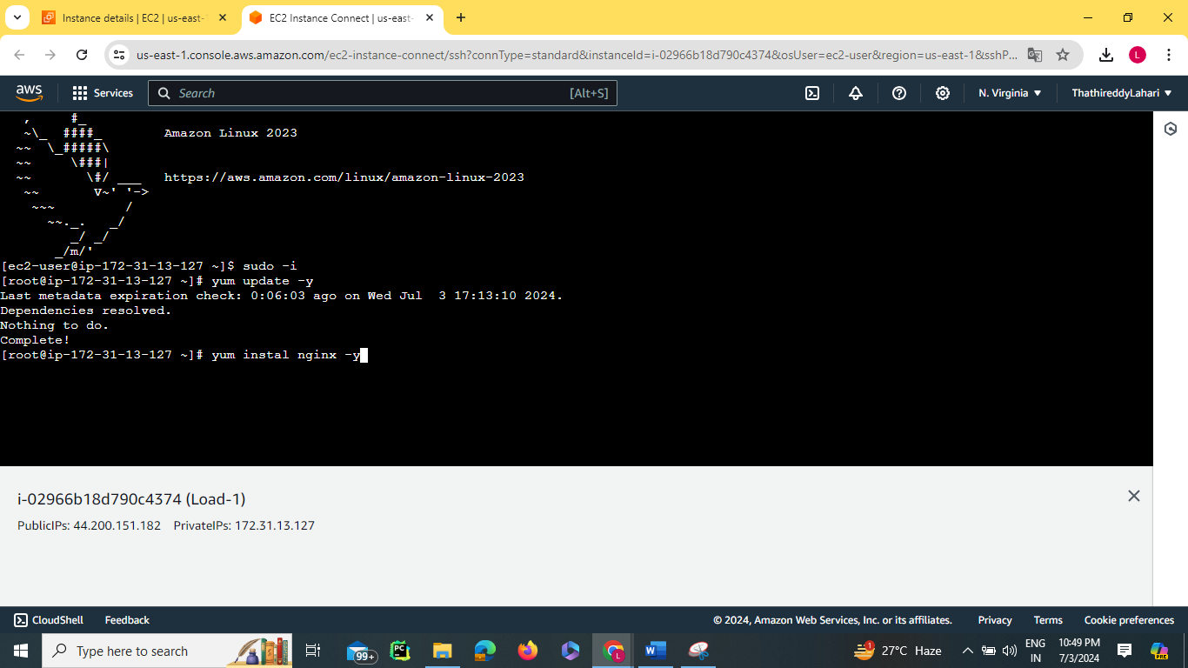

Completed the installation of nginx

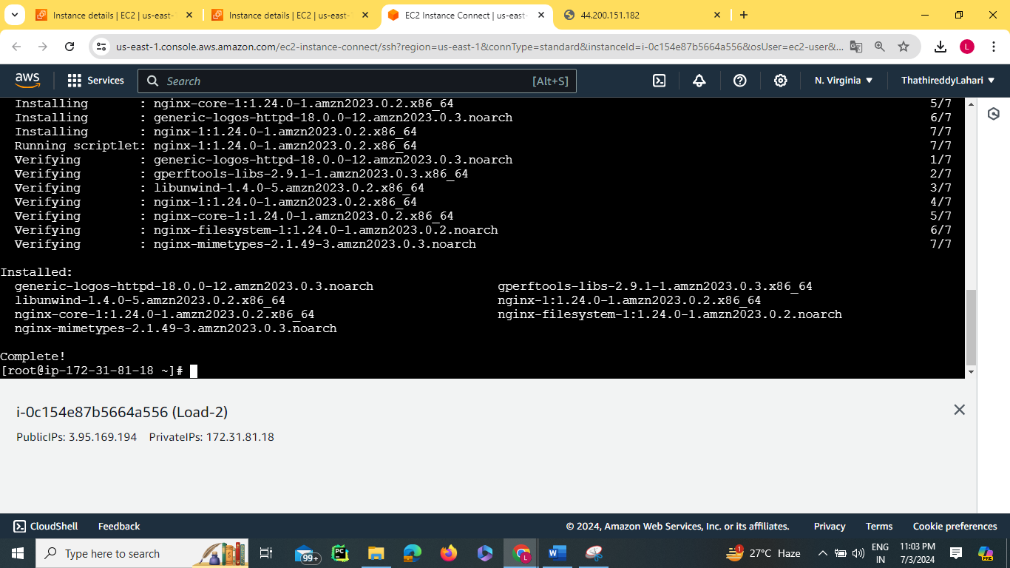

Cd /usr/share/nginx/html command is used to know the path of the nginx

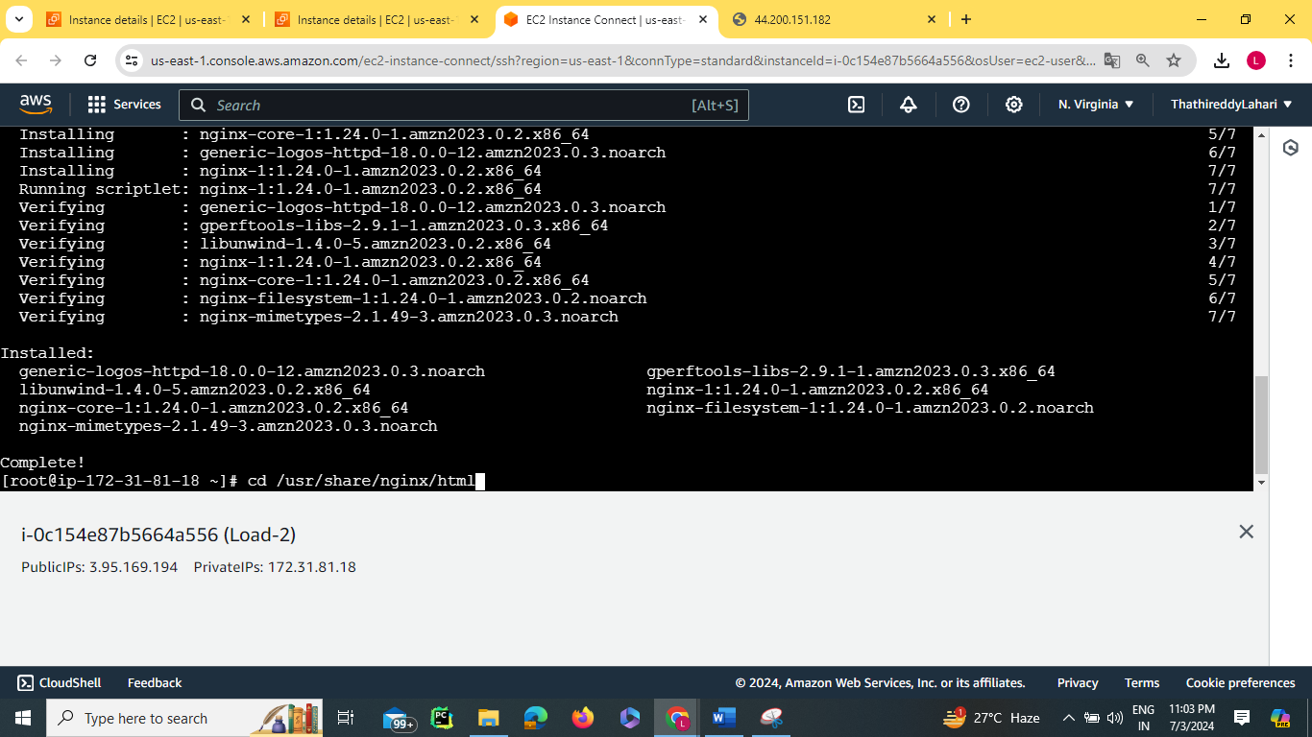

ls shows the list

rm -rf command is used to remove the file recursively and create a file

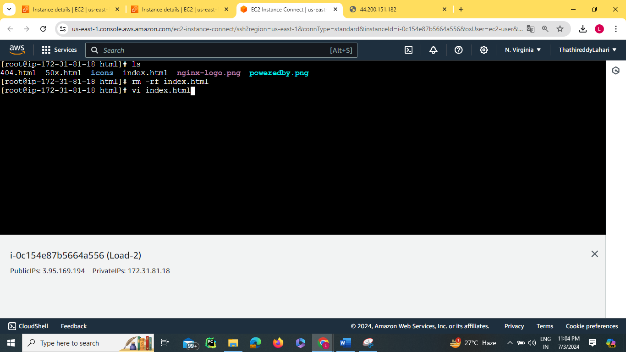

Click i to insert the data in vi file and type the data

save the file by esc+shift+:

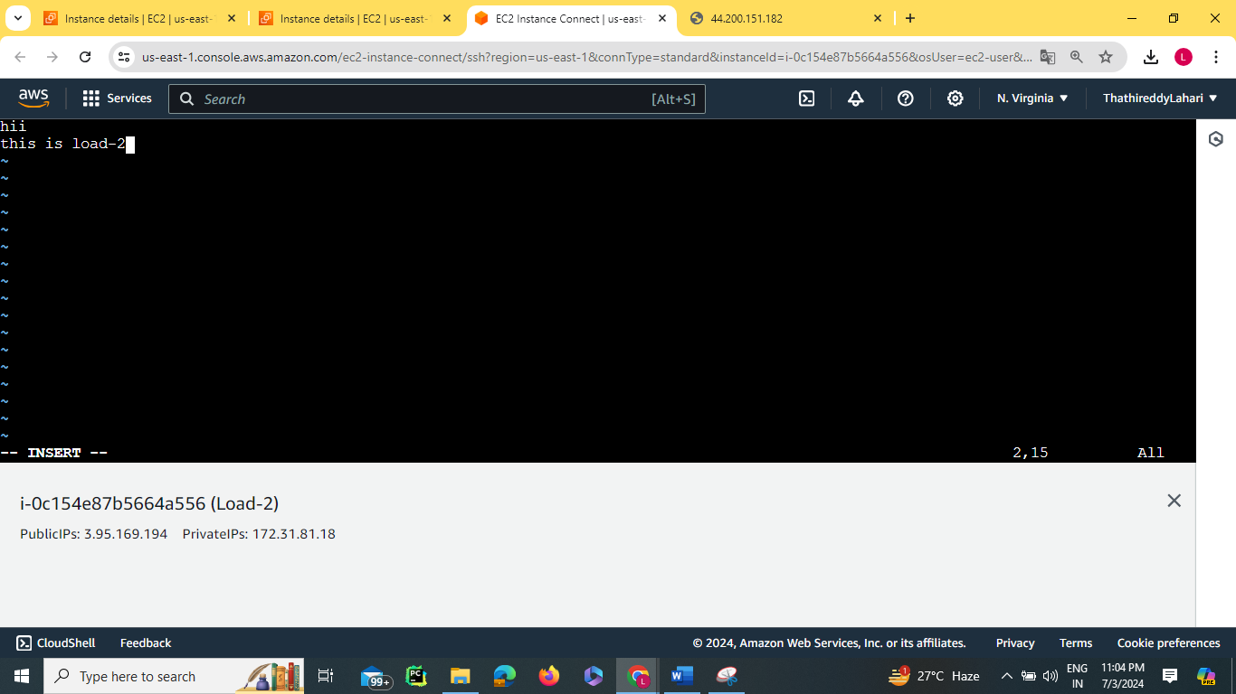

To refresh we use systemctl

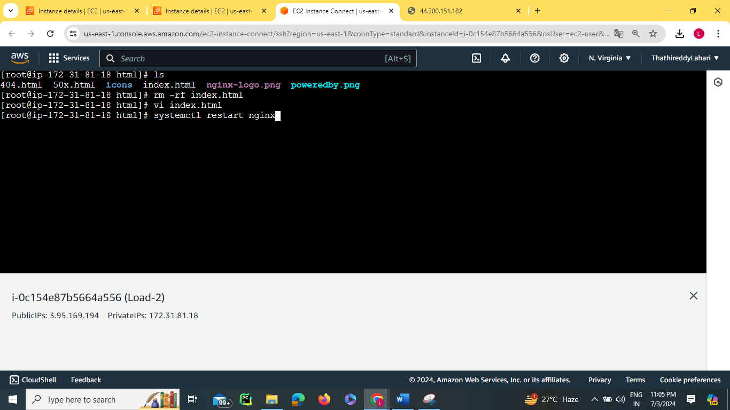

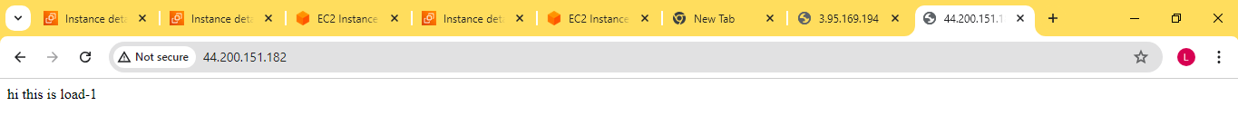

By pasting the public IP address in a new tab we get the data typed in vi file.

Do the same process for instance 2 and instance 3

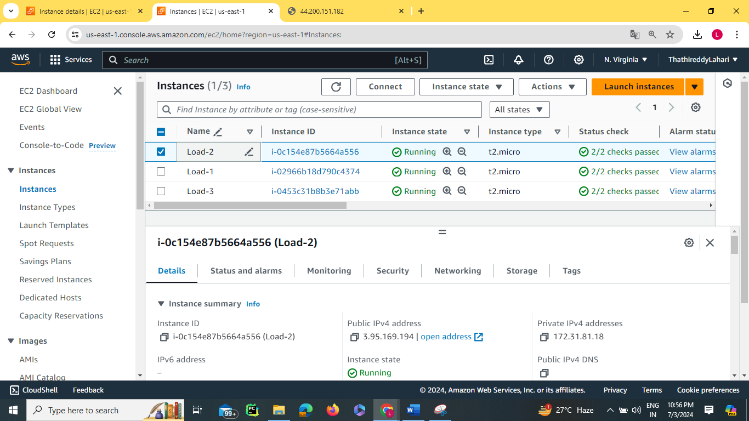

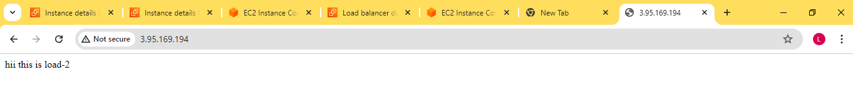

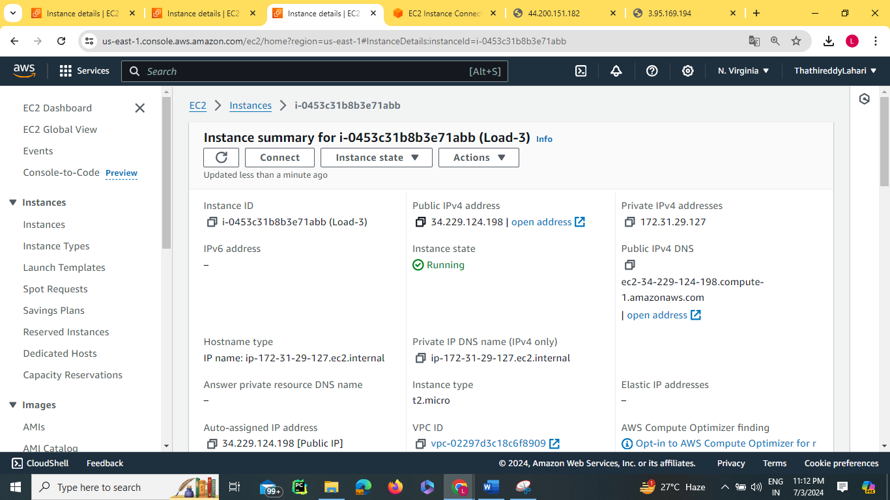

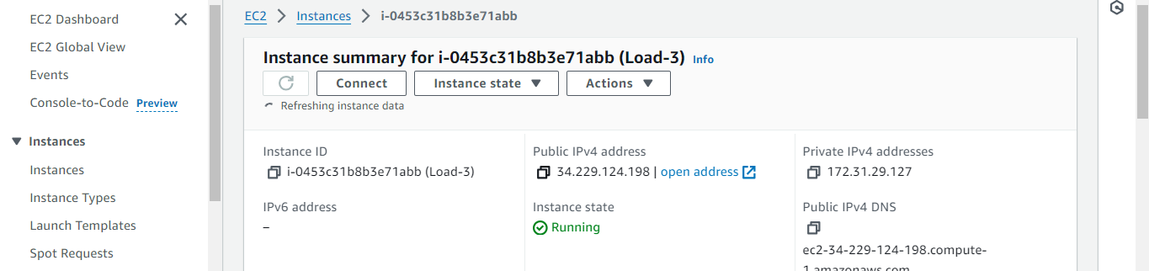

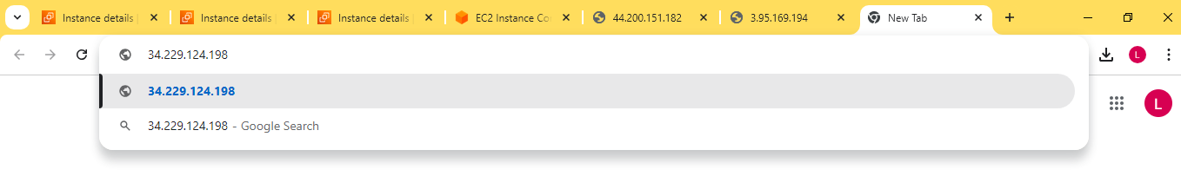

Pasted the public ip address of load 3 in a new tab to get what data we typed in vi file

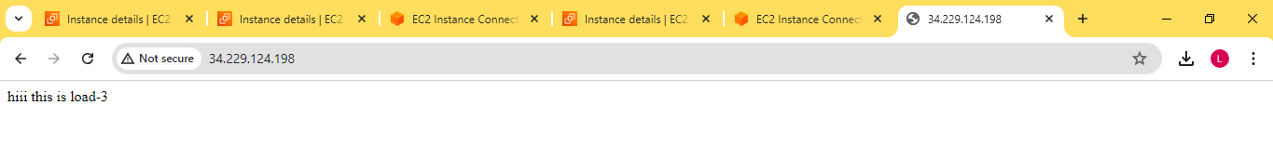

Create Target file

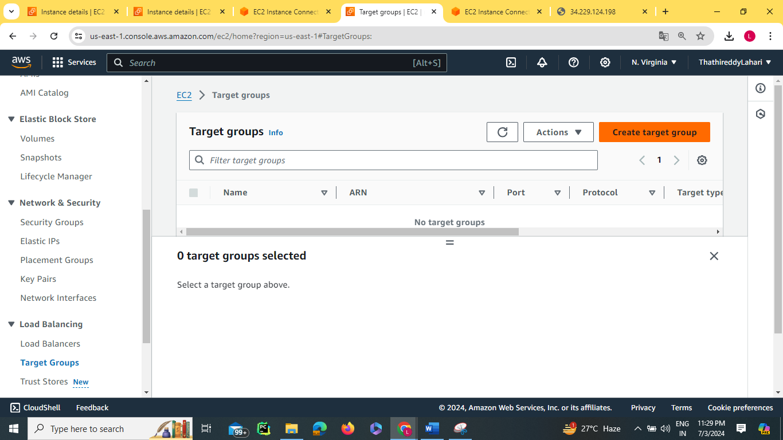

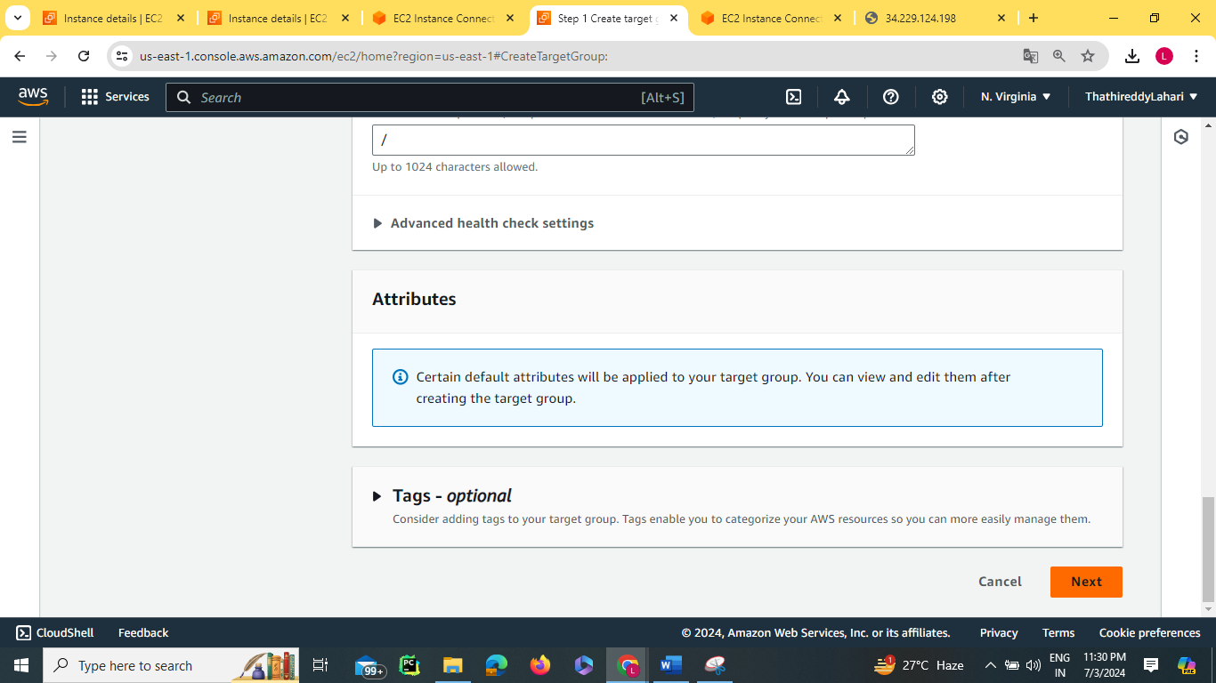

In Register targets click on 3 instances and click on include as pending below at last click on create target file

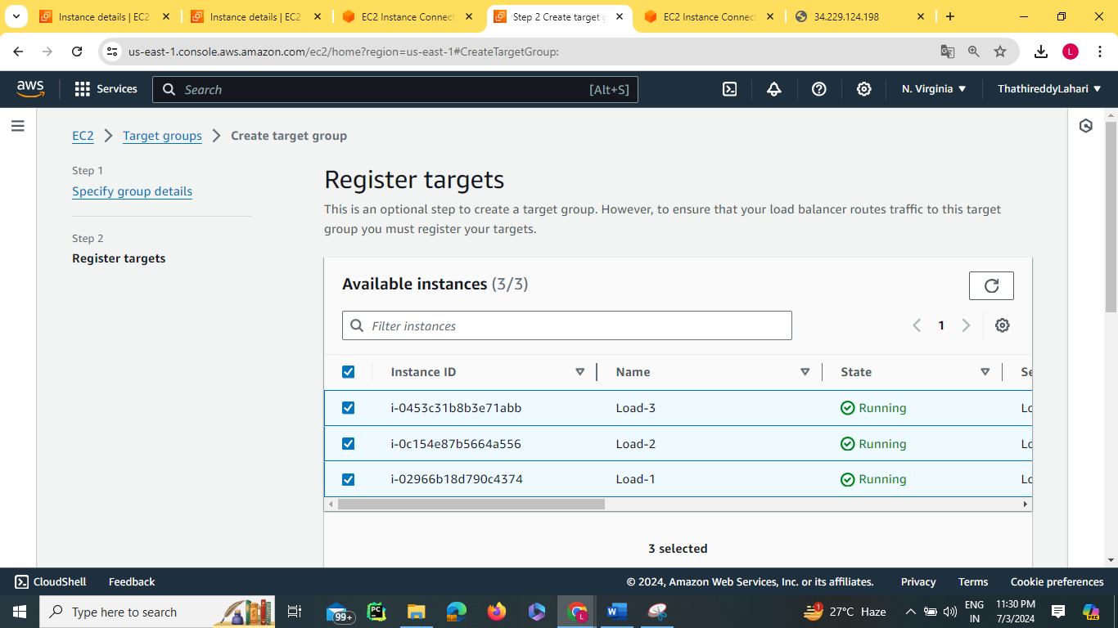

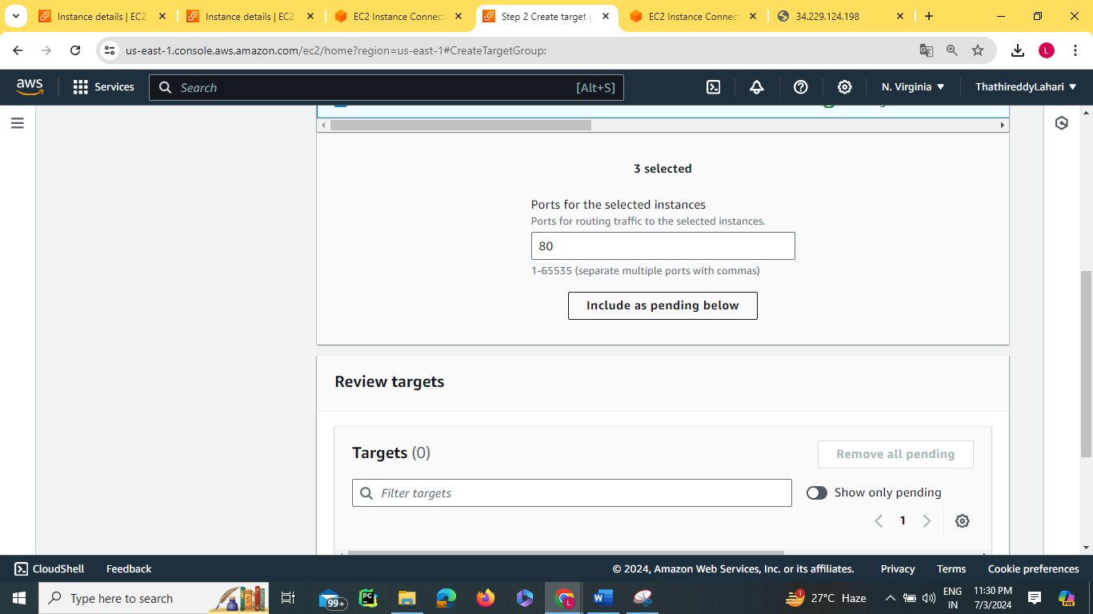

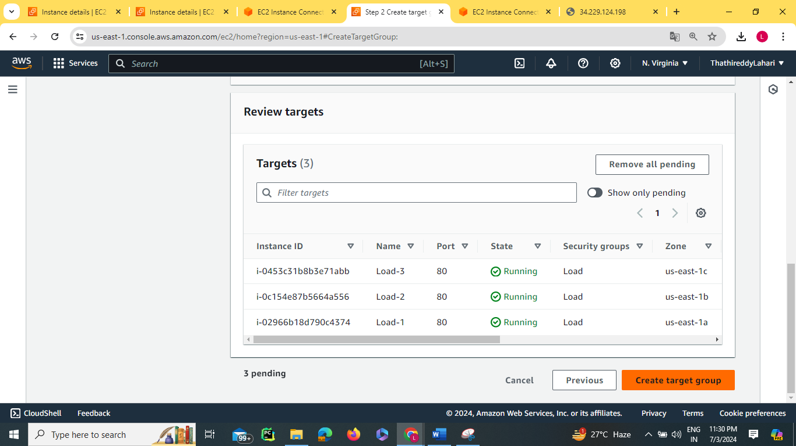

Click on Create target group

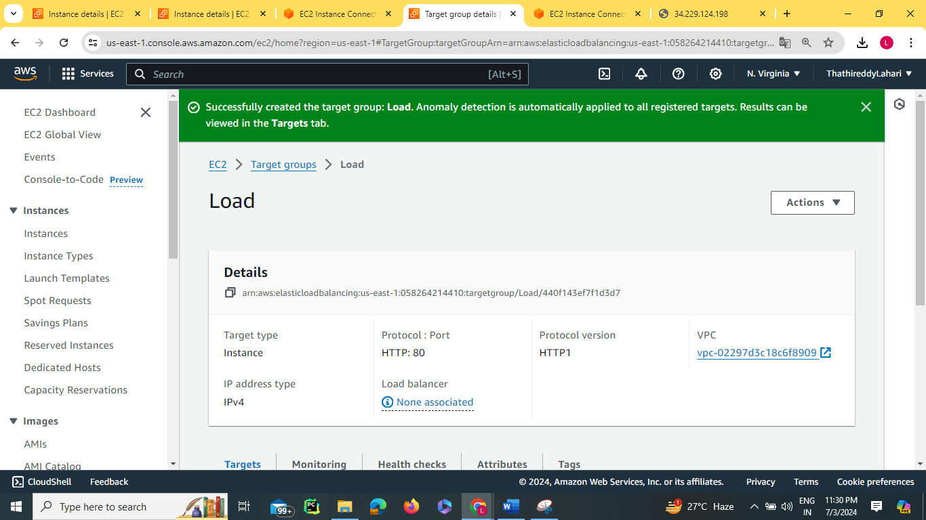

Finally, target group is created

Click on Load Balancers and create the load balancer

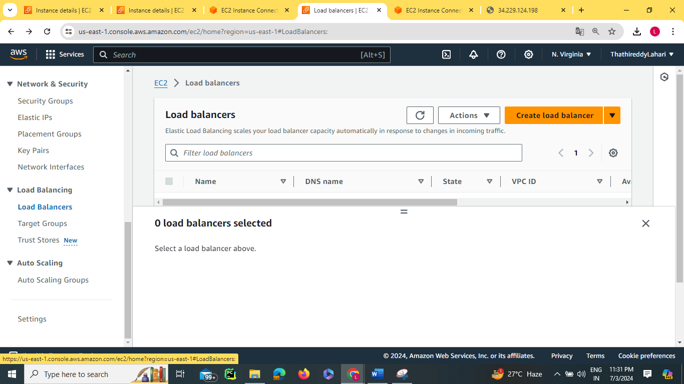

Click on the type of balancer we need

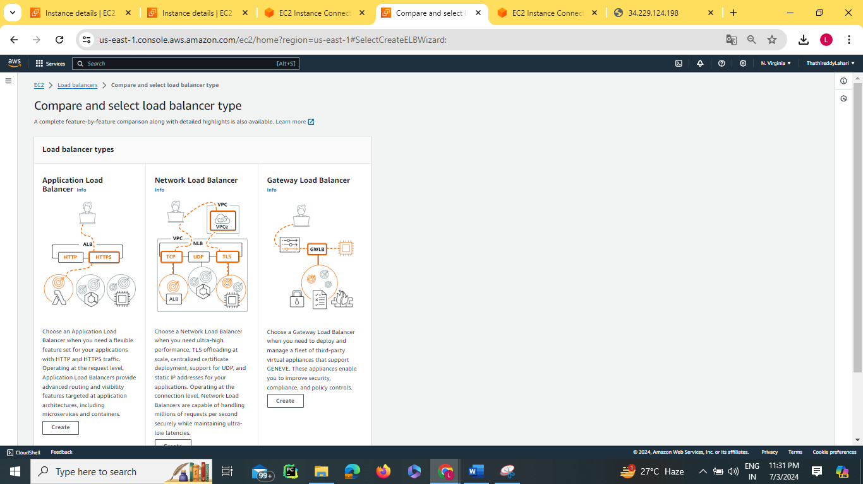

Mappings subsets with different availability zones

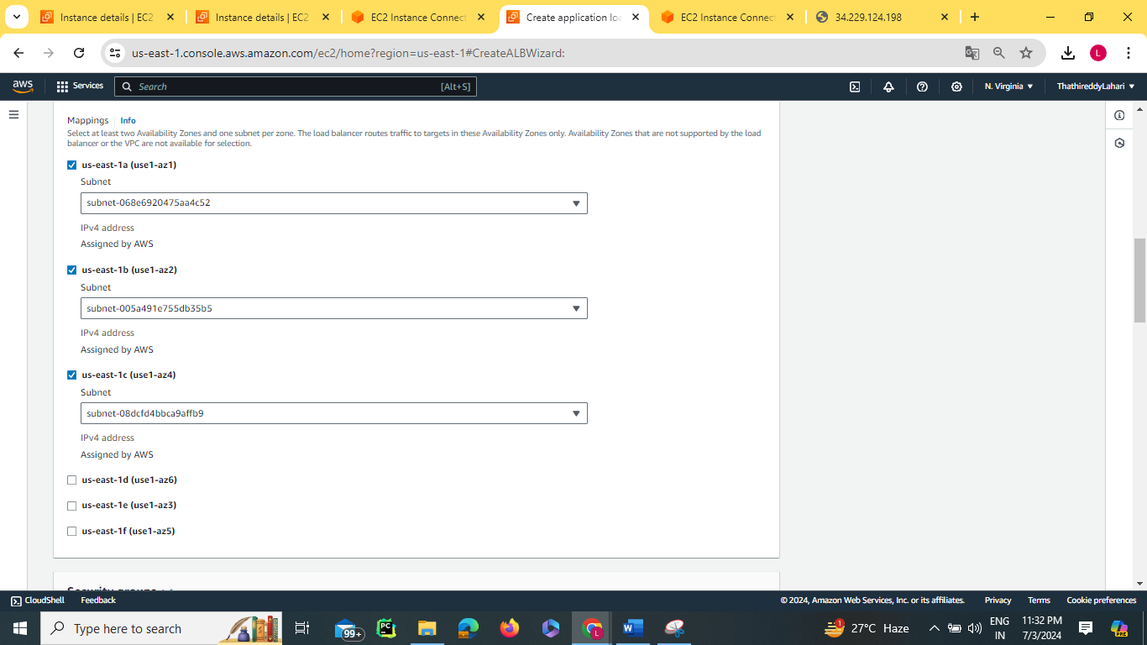

Remove the default security group and select the security group we created. Attach the target group we created. Click on create load balancer. Load balancer was created successfully

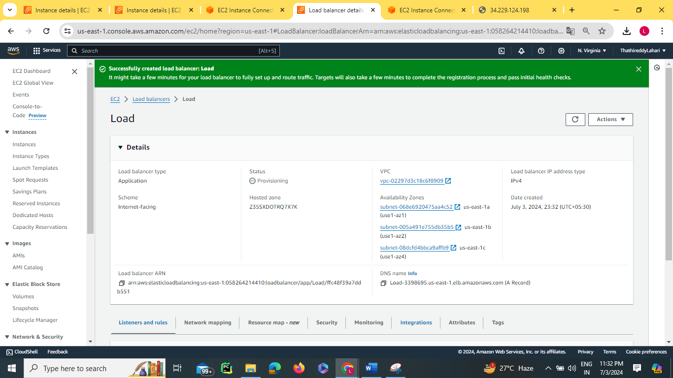

Copy the DNS name

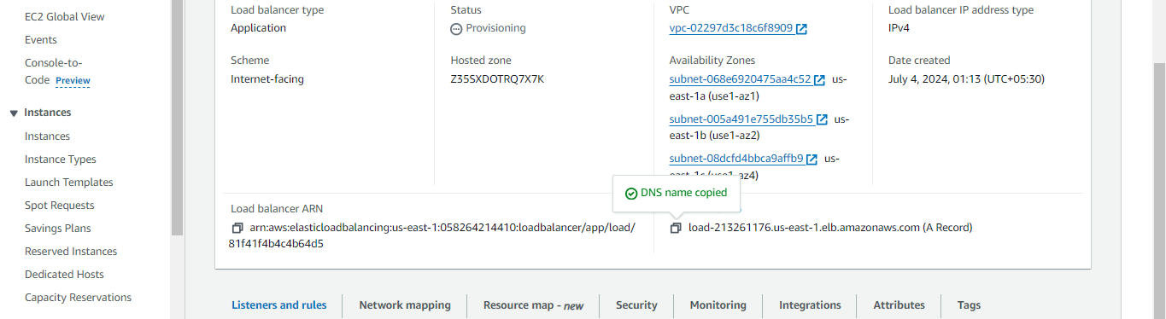

Paste it on Chrome



By refreshing we can get the provided data in 3 different instances

